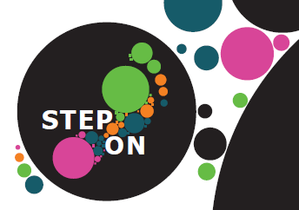
Step On Employment Team - Referral Form

The Step On team is an Individual Placement and Support service (IPS). They provide IPS within Staffordshire and aim to enable service users, supported by secondary mental health services, to gain and maintain meaningful paid employment.

Step On contact details
Jennifer Hawkins - Step On Team Lead North Staffordshire 07515 191 219
Please send all referrals to stepon@combined.nhs.uk

Client Details
Name: | NHS No:
Date of Birth: | National Ins No:
Address: | Post Code:
Telephone: | Email:
Mental health pathway/team: | Care Coordinator details:

Mental Health needs: eg:- diagnosis, medication impact on functioning, risk markers. etc, | Benefit Status: please identify if known  ESA Work Related Activity group  ESA Support group  Universal Credit limited capacity for work  Universal Credit limited capacity for work or work related activity
Service user consent to share information:
- I agree that the information given on this form can be shared with Step On.
- Please tick if service users consent is gained to share information.
Name & Position of Referrer:  Referrer contact details: | Referrer’s Signature:  Date:

